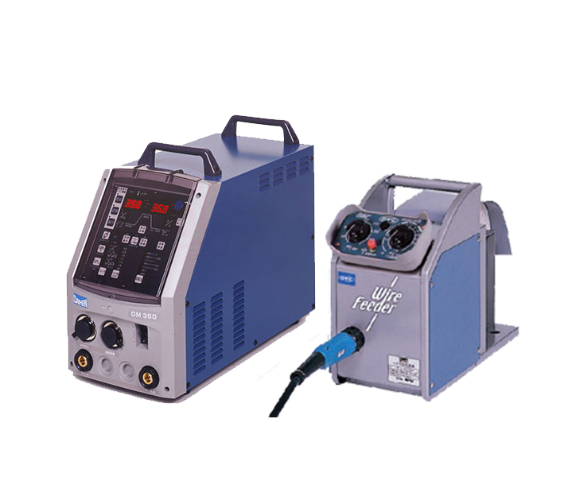

DM350/500 FULL DIGITAL INVERTER CO2/MAG WELDING MACHINE CARBON DIOCIDE GAS SHIELDED ARC WEIDING
MAG welding is welding in an atmosphere of reacting gases, or as it is also called: shielded by an active gas. This means that the gas is separated in the arc and to a smaller or larger extent reacts with the weld pool. CO2 is mainly used as shielding gas which is why the process is also known as CO2 welding.
Application welding
Aluminium
Ordinary mild steels
Stainless steels
Copper and copper alloys

Advantage
Adopt OTC unique IGBT soft switching inverter control technology, Improve the inverter main frequency greatly (output frequency up to 80kHz).
Wide selection of arc characteristics which can meet the full range of needs of different processes,
and excellent arc stability during all-position welding;
The new four-wheel drive with wire feeder feedback control of the wire feeding device makes the wire feeding more precise and more stable;
It can be easily matched with personal computers, robots and special planes;
The welding performance can be expanded by configuring CAN communication.

Structure
The DM-350 is operated via a simple interface that revolves around a single knob that adjusts the voltage and current (wire speed) and visual buttons. A large LED is used to display settings and weld parameters, And four-feed rolls wire feeder. The buttons can easily be pushed even while wearing welding gloves.

Parameter
Power Supply | Model | DM-350 | DM-500
Input Voltage | V,Hz | - phase electricity,  380V±10%，50/60Hz | 3-phase electricity，380V±10%，50/60Hz
Rated Input capacity | KVA | 15.9 (13.4kW) | 25.8 (24.0kW)
Output Current Range | A | 30～350 | 30～500
Rated Load Duration | % | 60 | 100
Dimensions (W*D*H) | mm | 250×640×430 | 300×655×595
Weight | kg | 30 | 51
Wire Feeder | Model | CM-7401 | CM-7401
Gas Flow Regulator | Model | W-198-36v | W-198-36v

